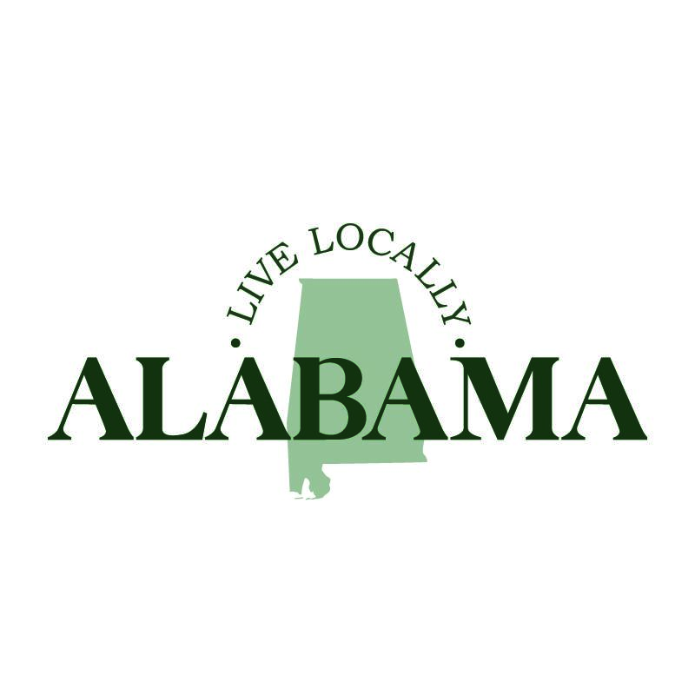

The following social media copy is available to post with corresponding graphics and videos. You are welcome to adjust the captions to incorporate language that promotes your municipality. These are meant to be spread out over the course of one to two months. Please remember to tag the Alabama League of Municipalities on our platforms and use the hashtag #LiveLocallyAlabama. We have Facebook, Twitter, Instagram, LinkedIn and YouTube. You are also encouraged to follow us and like/share the League’s posts. Thank you!

Launch Day Graphic (several to choose from)
Copy 1: I am thrilled to support Live Locally Alabama, a quality-of-life campaign led by local officials from Alabama’s 465 cities and towns. This initiative was developed to encourage civic engagement, instill community pride and highlight the crucial role municipal government plays in the daily lives of Alabamians. Learn more at: https://almonline.org/LiveLocallyAlabama.aspx. #LiveLocallyAlabama

Copy 2: The city/town of FILL IN BLANK is thrilled to support Live Locally Alabama, a quality-of-life campaign developed to enhance the well-being of our communities. Learn more at: https://almonline.org/LiveLocallyAlabama.aspx. #LiveLocallyAlabama

Campaign Video
Copy: Where does Alabama start? It starts with You, locally. We hope you will take a moment to watch the new #LiveLocallyAlabama campaign video. Get engaged by visiting: https://almonline.org/LiveLocallyAlabama.aspx.

Support Your Community Carousel of Graphics (these can be used all together or the question graphic can be used by itself)
Copy: In the heart of Alabama, local governments work to enhance the quality of life for their communities. They ensure public safety, attract economic investments, maintain infrastructure and promote sustainability. They also provide recreational, educational and work opportunities along with celebrating the arts through festivals and cultural events.

Living locally is more than a choice — it’s a commitment to support Alabama. Let’s build a brighter future together! Discover how you can make a difference at https://almonline.org/LiveLocallyAlabama.aspx. #LiveLocallyAlabama

What Do You Love Most About Your Community?
Copy 1: The heart of Alabama starts locally, whether it’s the shop down the street or the restaurant next door. It's in the streets we drive and the parks and festivals we love. We each hold memories and dreams that make Alabama a special place to live, work and play. Tell us, what do you love most about your community? #LiveLocallyAlabama

Copy 2: What do you love most about Name of Municipality? For us, it’s the people. You inspire us to serve our community every day. We can’t wait to see all of your positive answers! In the meantime, we encourage you to learn more about the new #LiveLocallyAlabama campaign at https://almonline.org/LiveLocallyAlabama.aspx.

